Part 1: Research Web Vulnerabilities
In the Lab Report file, describe each of the Top 10 vulnerabilities and summarize the recommendations for preventing each attack.
- Injection: Untrusted data sent to an interpreter can lead to SQL, NoSQL, OS, and LDAP injection attacks.
Prevention: Use parameterized queries, validate inputs, and apply least privilege principles.
- Broken Authentication: Flaws in authentication allow credential theft and unauthorized access.
Prevention: Enforce multi-factor authentication, securely hash passwords, and avoid exposing session IDs in URLs.
- Sensitive Data Exposure: Inadequate protection of sensitive data can lead to theft.
Prevention: Encrypt data in transit and at rest, use strong encryption standards, and disable caching for sensitive data.
- XML External Entities (XXE): Misconfigured XML processors can expose internal files or enable attacks.
Prevention: Use secure XML parsers, disable external entity processing, and validate XML inputs.
- Broken Access Control: Lack of restrictions allows unauthorized access to data.
Prevention: Implement role-based access control, test access controls, and validate user permissions server-side.
- Security Misconfiguration: Poor configurations can expose vulnerabilities.
Prevention: Regularly audit configurations, disable unnecessary features, and keep software updated.
- Cross-Site Scripting (XSS): Unvalidated data in web pages can execute malicious scripts.
Prevention: Use output encoding, validate inputs, and implement Content Security Policies.
- Insecure Deserialization: This flaw can lead to remote code execution.
Prevention: Avoid deserializing untrusted data and monitor deserialization processes.
- Using Components with Known Vulnerabilities: Outdated libraries can be exploited.
Prevention: Regularly update components and use tools to identify vulnerabilities.
- Insufficient Logging & Monitoring: Lack of monitoring allows undetected attacks.
Prevention: Implement robust logging, monitor security events, and integrate incident response workflows.

Part 2: Attack a Vulnerable Web Application
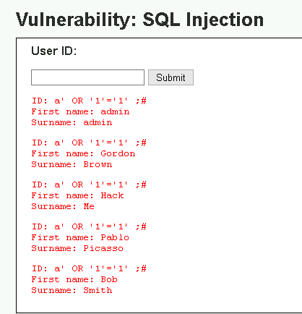
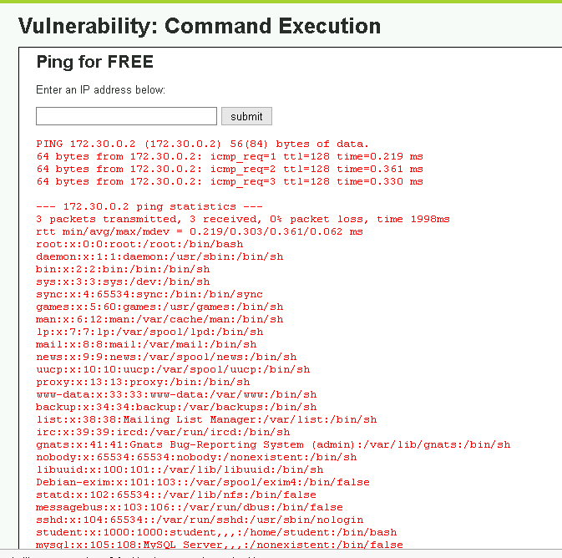
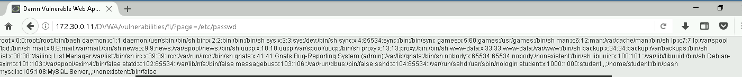

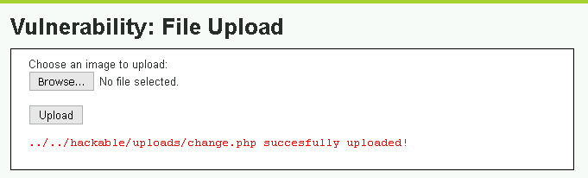

Record the results of this test and summarize the steps used to complete the password change.
The password change test was successful. The file inclusion attack executed the change.php script, altering the administrator's password to changedit. After testing the login and it working, (Username: admin, Password: changedit), this confirmed the exploit worked as intended.
The process started by accessing the CSRF page in DVWA, entering a new password (test), and noting the query string in the URL after submission. A PHP file (change.php) with the CSRF query string was created in Notepad and saved to the desktop. This file was uploaded via the DVWA File Upload page, which confirmed the upload and provided its server location (../../hackable/uploads/change.php). The File Inclusion page was then used to execute the script by modifying the URL, successfully displaying a confirmation message. Finally, the password change was verified by logging out and back in with the new credentials (admin:changedit).



